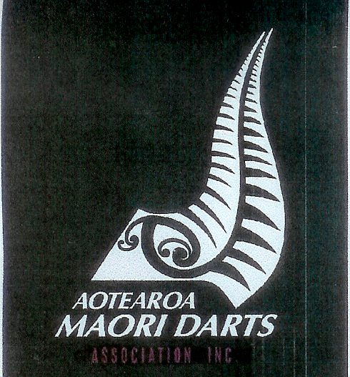
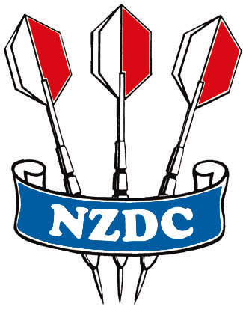
New Zealand Darts Council Inc
PO Box 42042
Homedale 5049
Wainuiomata AOTEAROA NZ MAORI CHAMPIONSHIP ENTRIES
COVER SHEET
ASSOCIATION: ________________________ SEASON: 2021

Please List Last Names in Alphabetical Order (A-Z)
NZDC  Mem No | First Name | Last Name  (In alphabetical order) | Men’s  Singles  ($30.00) | Ladies Singles  ($30.00) | Men’s Pairs  ($30 per pair) | Ladies Pairs  ($30 per pair) | Total $ Amount Enclosed | Referee  (If not signed below) | Iwi/Hapu

Total Amount payable to NZ Darts Council
Declaration: I _____________________________ confirm that the above players are eligible to enter the Aotearoa NZ Maori Darts Championships and are of NZ Maori descent
Signed ___________________________ Contact Number_________________________
Signed ___________________________ Contact Number_________________________

