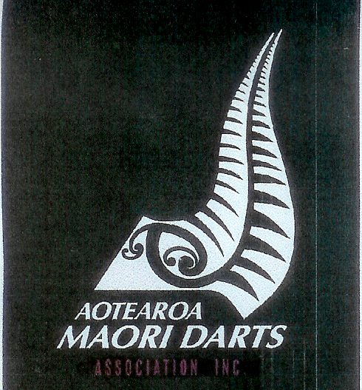
AOTEAROA NZ MAORI CHAMPIONSHIP
ENTRY FORM 2021

Return To New Zealand Darts Council Inc
PO Box 42042
Homedale 5049
Wainuiomata
No Later Than 2 October 2021

Association _______________________________

MEN`S SINGLES

 | Mem  No | First Name | Last Name
1
2
3
4
5
6
7
8
9
10
11
12
13
14

Secretary …………………………………………. Date / /

AOTEAROA NZ MAORI CHAMPIONSHIP
ENTRY FORM 2021

Return To New Zealand Darts Council Inc
PO Box 42042
Homedale 5049
Wainuiomata
No Later Than 2 October 2021

Association _______________________________

MENS PAIRS

 | Mem  No | First Name | Last Name |  | Mem No | First Name | Last Name
1 |  |  |  | &
2 |  |  |  | &
3 |  |  |  | &
4 |  |  |  | &
5 |  |  |  | &
6 |  |  |  | &
7 |  |  |  | &
8 |  |  |  | &
9 |  |  |  | &
10 |  |  |  | &
11 |  |  |  | &
12 |  |  |  | &
13 |  |  |  | &
14 |  |  |  | &

Secretary …………………………………………. Date / /

AOTEAROA NZ MAORI CHAMPIONSHIP
ENTRY FORM 2021

Return To New Zealand Darts Council Inc
PO Box 42042
Homedale 5049
Wainuiomata
No Later Than 2 October 2021

Association _______________________________

LADIES SINGLES

 | Mem  No | First Name | Last Name
1
2
3
4
5
6
7
8
9
10
11
12
13
14

Secretary …………………………………………. Date / /

AOTEAROA NZ MAORI CHAMPIONSHIP
ENTRY FORM 2021

Return To New Zealand Darts Council Inc
PO Box 42042
Homedale 5049
Wainuiomata
No Later Than 2 October 2021

Association _______________________________

LADIES PAIRS

 | Mem  No | First Name | Last Name |  | Mem No | First Name | Last Name
1 |  |  |  | &
2 |  |  |  | &
3 |  |  |  | &
4 |  |  |  | &
5 |  |  |  | &
6 |  |  |  | &
7 |  |  |  | &
8 |  |  |  | &
9 |  |  |  | &
10 |  |  |  | &
11 |  |  |  | &
12 |  |  |  | &
13 |  |  |  | &
14 |  |  |  | &

Secretary …………………………………………. Date / /

